# **CSYE 7245 - Big Data Sys and Int Analytics**

## **Lab - Fastapi**

### **Team Information:**

|  |  |
| --- | --- |
| **Name** | **NUID** |
| Tanvi Gurav | 001306848 |
| Keerti Ojha | 001050173 |
| Priyanka Malpekar | 001302741 |

**Lab Completion date** : 10th March ‘21

# **About**

This lab leveraged the FastAPI framework for building APIs with Python 3.6+ based on standard Python type hints. In this lab we worked on 2 examples one was just Fastapi demo and other we created a fastapi that can be used to track investors buying and selling on the stock-market.

In addition to serving PUT and GET requests, the endpoint stores all data on DynamoDB.



The key features are:

* Fast: Very high performance, on par with NodeJS and Go (thanks to Starlette and Pydantic). [One of the fastest Python frameworks available](https://fastapi.tiangolo.com/#performance).
* Fast to code: Increase the speed to develop features by about 200% to 300%. *
* Fewer bugs: Reduce about 40% of human (developer) induced errors. *
* Intuitive: Great editor support. Completion everywhere. Less time debugging.
* Easy: Designed to be easy to use and learn. Less time reading docs.
* Short: Minimize code duplication. Multiple features from each parameter declaration. Fewer bugs.
* Robust: Get production-ready code. With automatic interactive documentation.
* Standards-based: Based on (and fully compatible with) the open standards for APIs: [OpenAPI](https://github.com/OAI/OpenAPI-Specification) (previously known as Swagger) and [JSON Schema](https://json-schema.org/).

# **Experiment Setup**

## **Prerequisites**

1. Installed below 3 libraries
   1. **pip3 install fastapi**
   2. **pip3 install uvicorn**
   3. **pip3 install iexfinance**
2. Created a free developer account in IEXCloud to access the current stock price using API tokens.

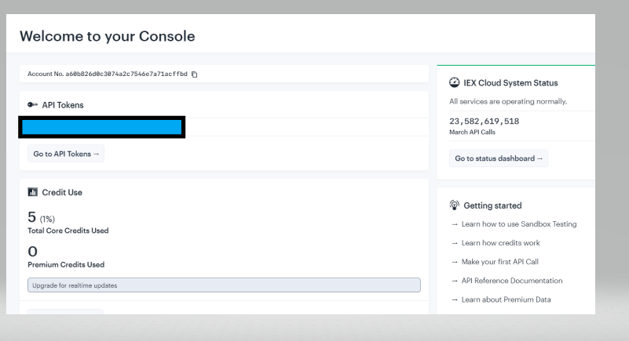

1. Created a table ‘Customer_Trades’ in AWS DynamoDB to store the data from API. 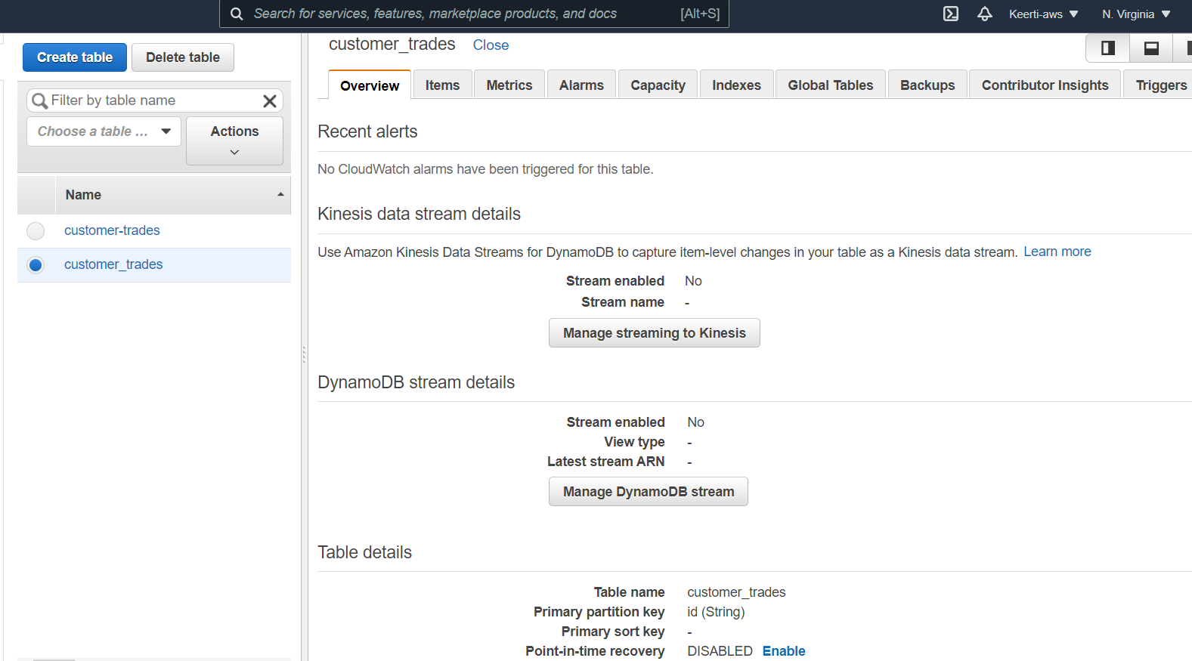

# **Example-1**

1. In python file we have code for root

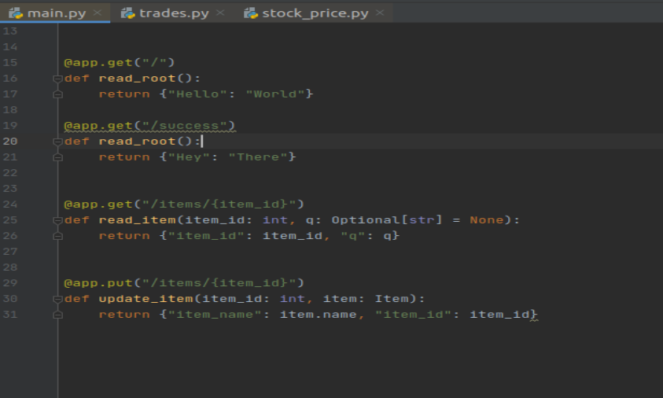

1. Used the below command highlighted command to run the app

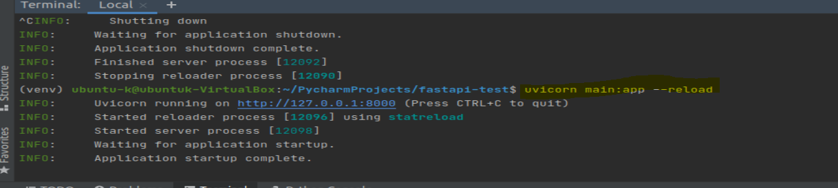

1. App is launched in port 127.0.0.1:8000 by default

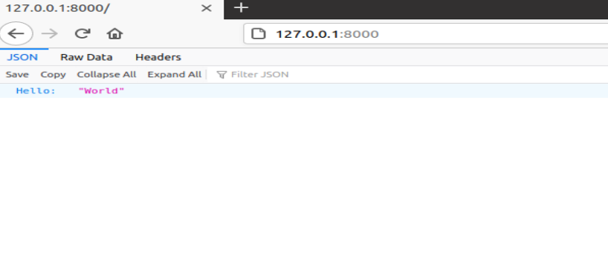

# **Result-1**

We also tested the docs and executed get and put methods.

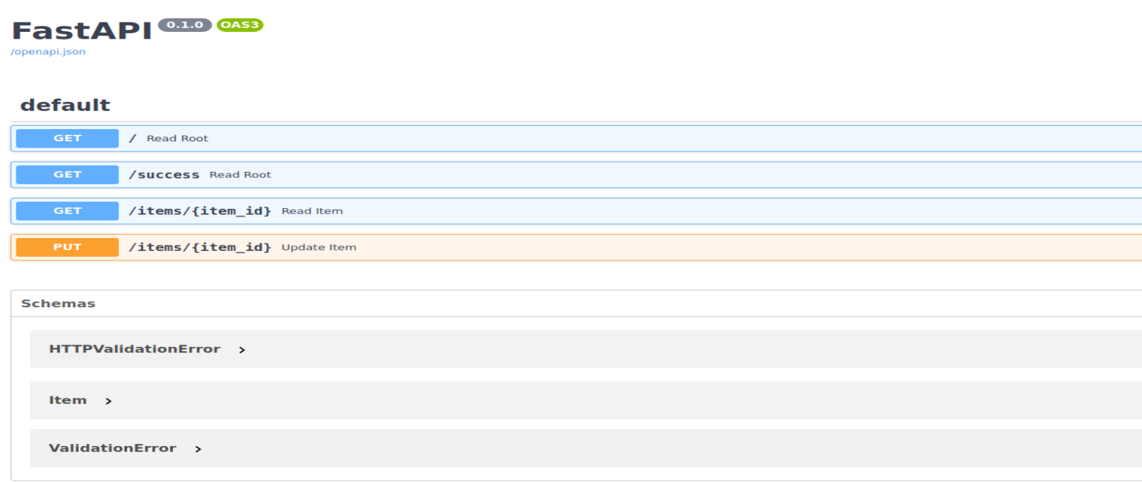

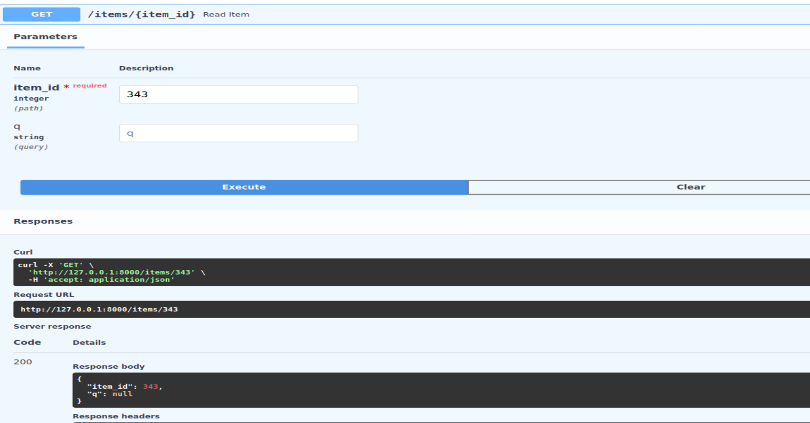

# **Example-2**

1. Here we are using trades.py and stock_price.py files

Stock_price.py contains the function that is fetching current stock price based on ticker.

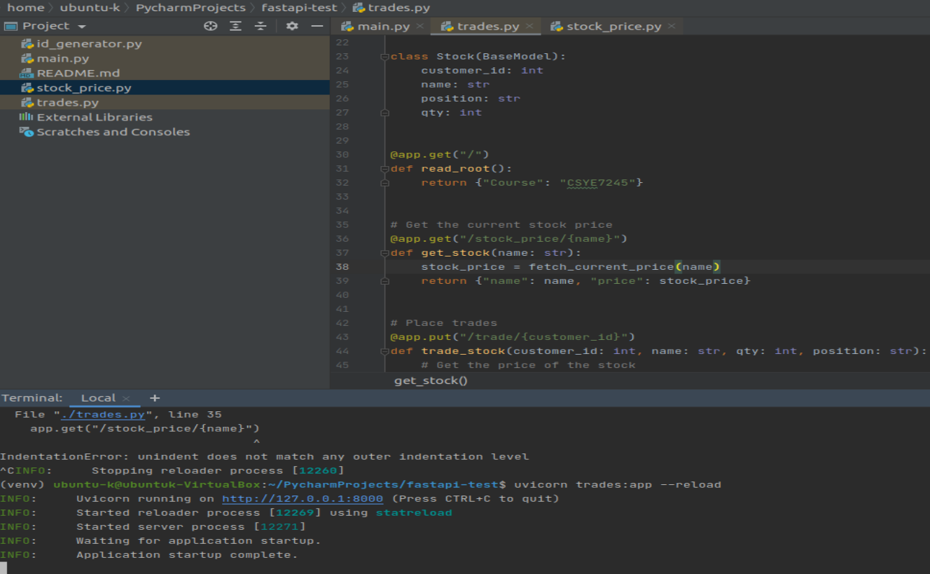

# **Result-2**

1. Executing get and post methods and checking DynamoDB records

* Getting current of stock of Apple

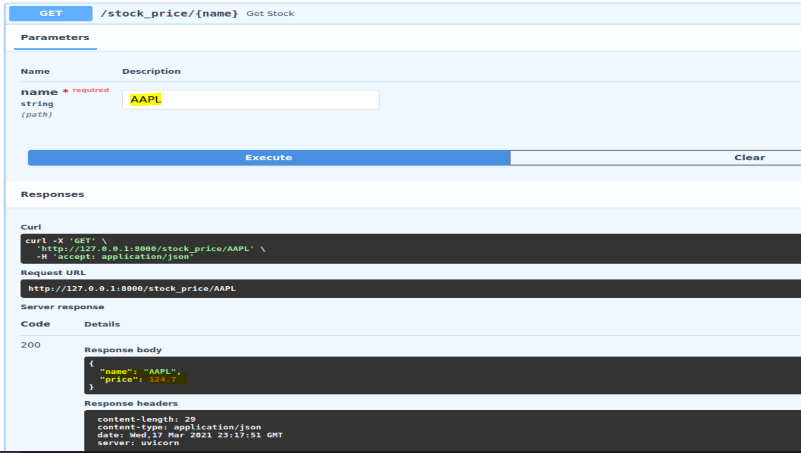

* Adding a customer entry in DynamoDB

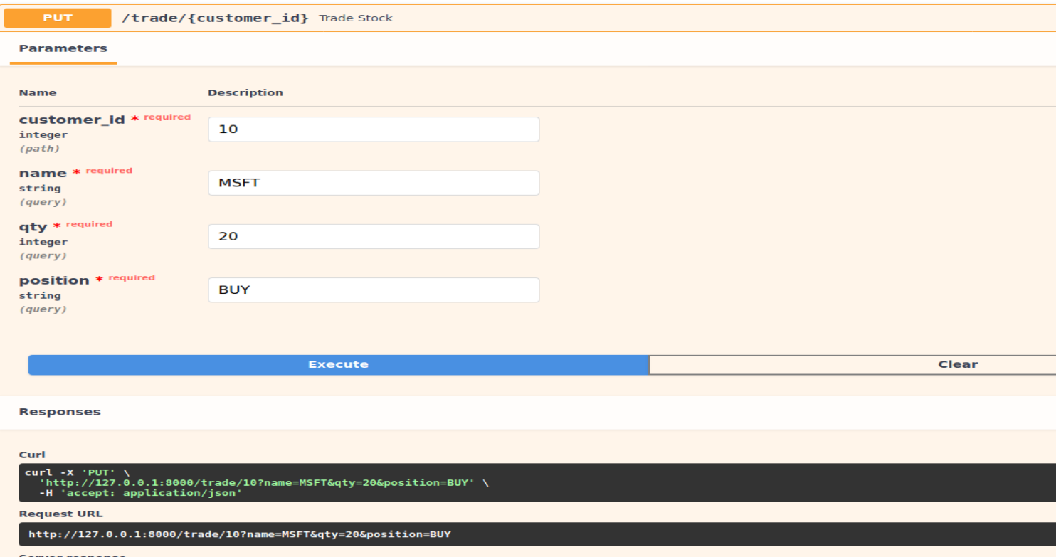

* Record is successfully stored

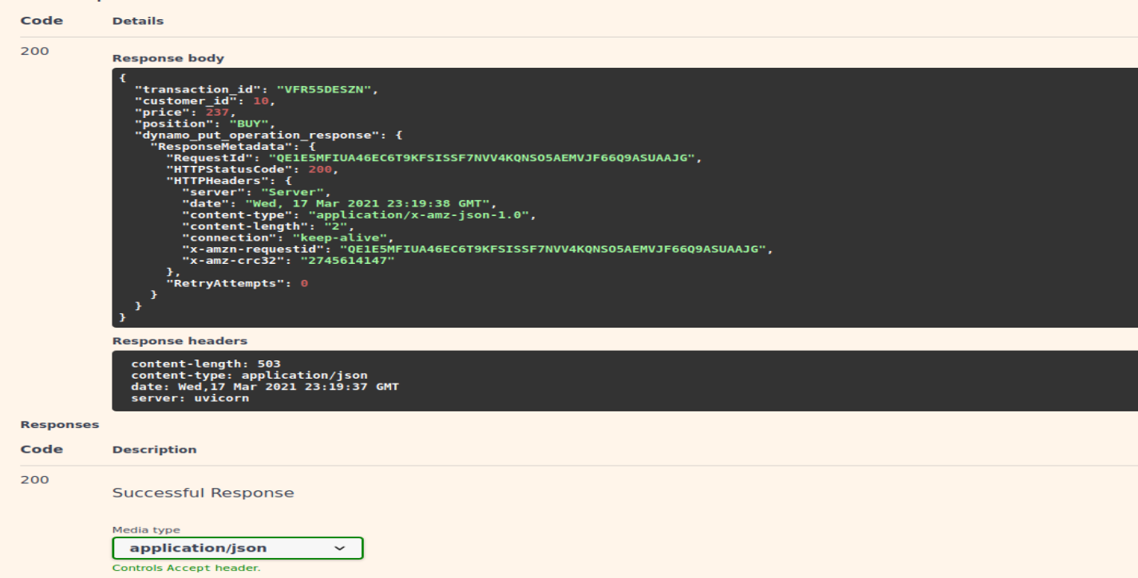

* AWS Dynamodb Table Console

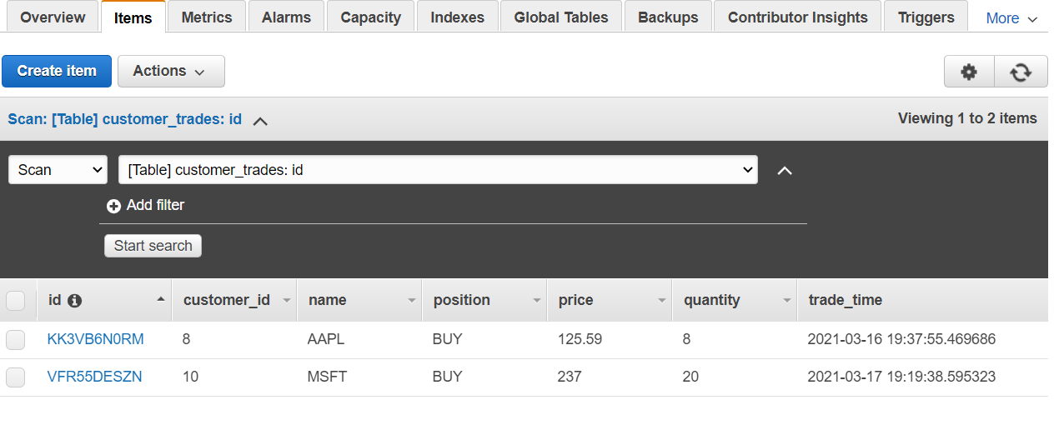

* Getting details of Customer records based on ID

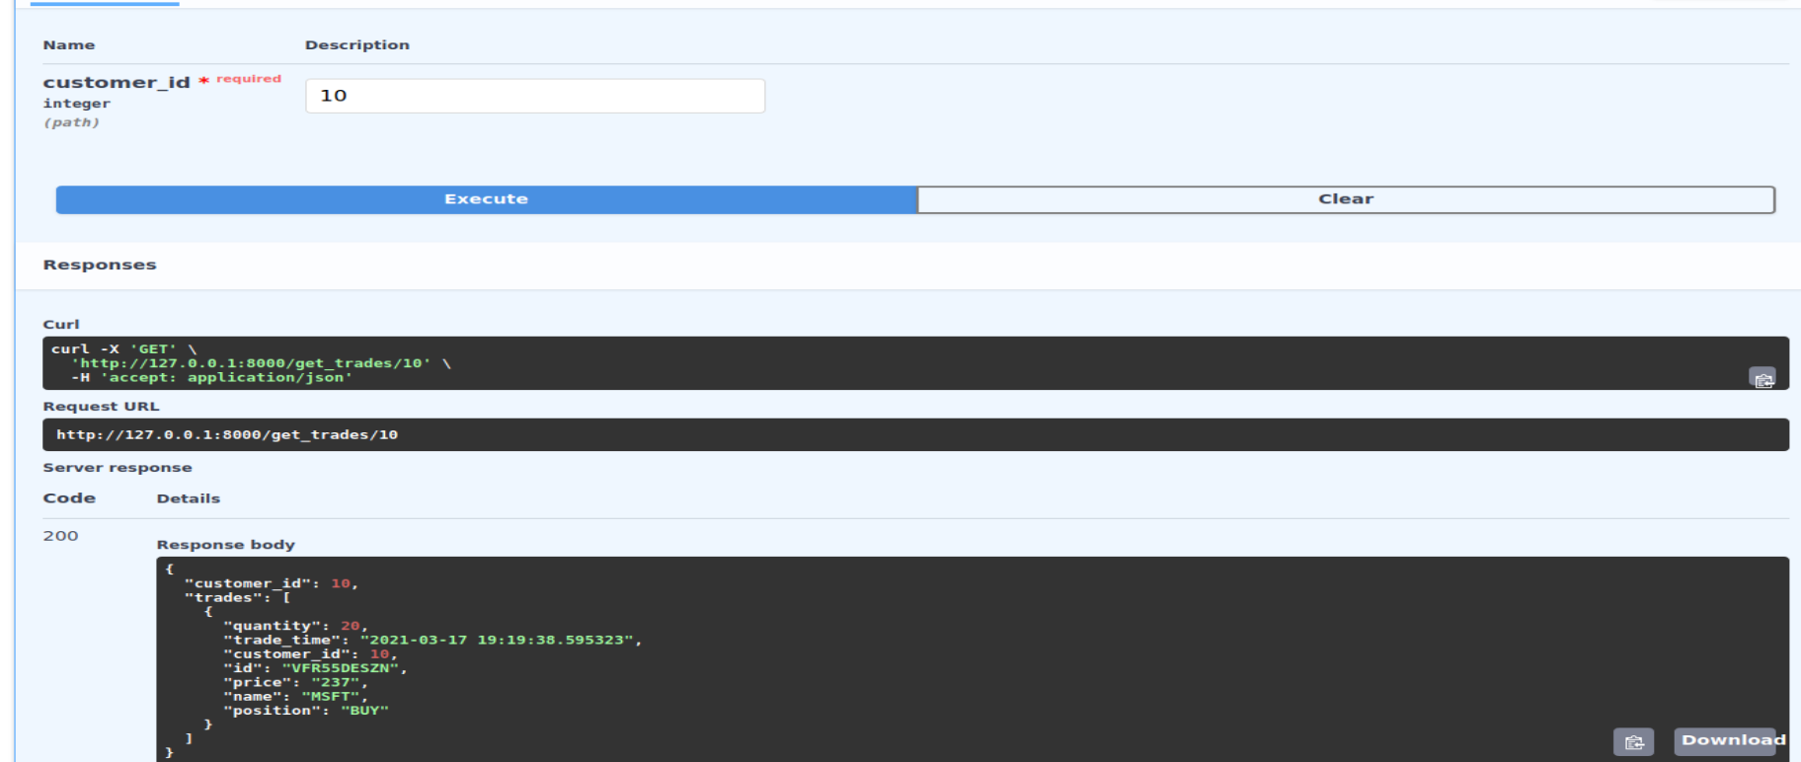

# 

# 

# 

# **Lesson Learned**

1. Learned to create an app using Fastapi framework
2. Learned to store and fetch data using api from AWS DynamoDB
3. Learned about default docs in Fastapi available to get and put data

# **References**

[**https://iexcloud.io/console/**](https://iexcloud.io/console/)

[**https://github.com/holladileep/CSYE7245-Spring2021-Labs/tree/main/fast-api**](https://github.com/holladileep/CSYE7245-Spring2021-Labs/tree/main/fast-api)

[**https://fastapi.tiangolo.com/**](https://fastapi.tiangolo.com/)